British Columbia Multi-Nation Missions Foundation PREPARING IMMIGRANT WOMEN FOR CANADIAN EMPLOYMENT $5,000
A $5,000 World Day of Prayer grant empowered 30 immigrant women from Ukraine to become successful employment candidates in Canada.
Working with two counselors and a volunteer, the women improved their English communication and interview skills, and received specific training in three service industries. Childcare and transportation were provided when required.
Ksenya’s story: Ksenya is a mother of three children. The program enabled her to improve her English skills, enhance her resume, and prepare for a job interview. Ksenya applied for a part-time job at Trinity Western University (TWU) and was offered the position. She subsequently applied for a higher position at TWU and secured it.
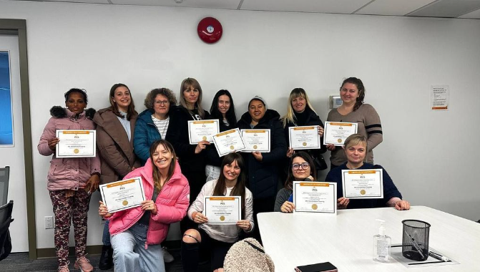

***
British Columbia The Willows – The Salvation Army PEACE PROGRAM – RECOVERING FROM VIOLENCE IN THE HOME $5.000
A $5,000 World Day of Prayer grant funded 2 eight-week sessions of the PEACE program for 16 children and their moms who had experienced violence. The sessions focused on Prevention, Education, Advocacy, Counselling, and Empowerment (PEACE). Each week, the ten moms and their children shared a meal together, followed by group lessons for the children and guest speakers for the moms.
Participant’s Testimonial: “In a time of family hardship and being bullied at school, the PEACE program was a safe and nurturing place for both J and I. For J it was a time to simply be himself without being afraid of being bullied. For myself, it was a lovely time of fellowship with the other Mamas. Also, what a treat to be fed supper every week like that, even taking our dietary challenges into consideration. The PEACE team and program rock and were much needed in a time of emotional and physical hardship. Thank you.”
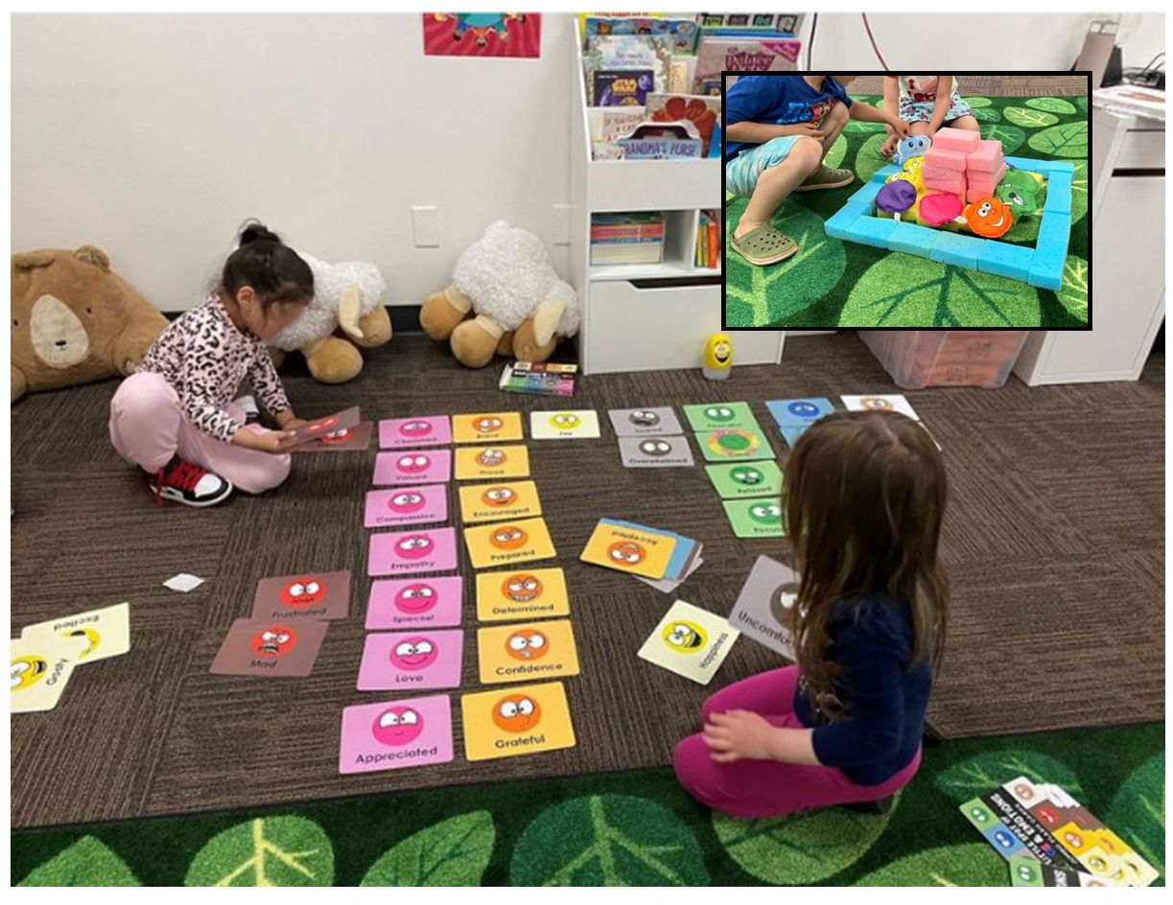
***
Alberta (IWIN) I’m Worth It Now BACKPACKS FOR HUMAN TRAFFICKING SURVIVORS $3,500
IWIN provides material support to non-profit agencies that offer services to survivors of human trafficking and commercial sexual exploitation.
84 backpacks filled with new clothing, personal care items and bracelets made by school children were financially funded by a $3,500 World Day of Prayer grant. A volunteer group of IWIN board members and local CWL members formed an assembly line to fill the bags. Prayer partners for the trafficking survivors were also given a bracklet.
Since its inception, IWIN has provided over 300 backpacks to non-profit agencies in
both Alberta and Saskatchewan. Recently (October 2023) the initiative expanded to include Dignity House in Manitoba and Elora House in Ontario.
Story from a backpack recipient: “I had the clothes I was wearing, jeans and a t-shirt. I had been wearing them for 3 days and having new clothes to change into meant so much. There were a lot of negative vibes attached to my old clothes. I can’t put into words how much it meant to have something to change into. I cried when I read the card, and wore the bracelet on my ankle for 3 straight months. It’s now hanging on my wall.”
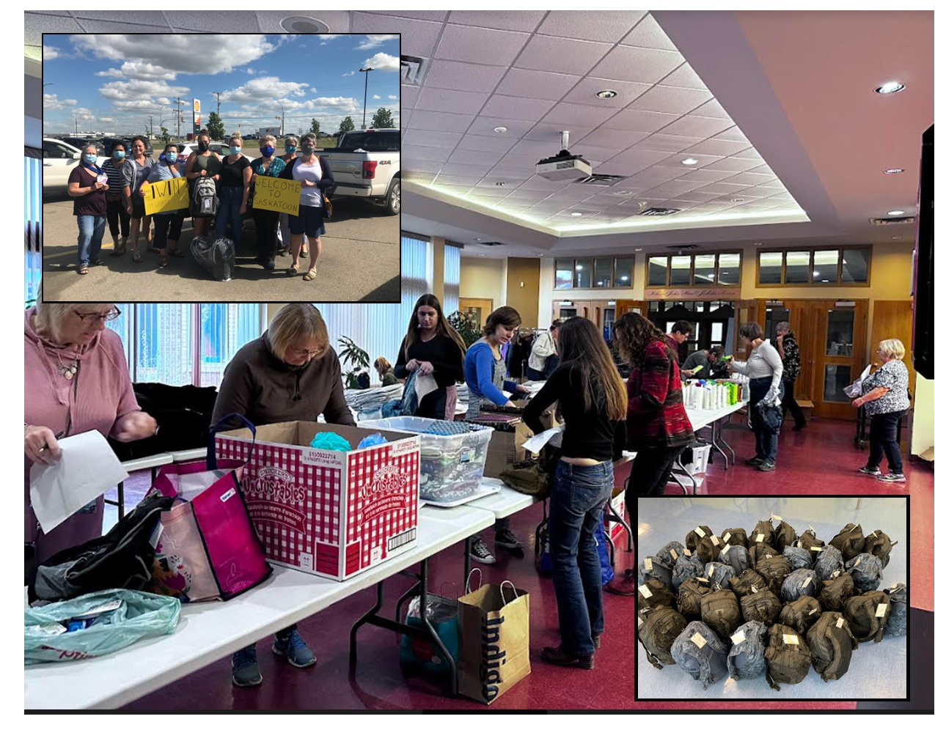
***
Manitoba Genesis House WHEN LOVE HURTS SUPPORT GROUP $3,500
Thirty women who had experienced assault by intimate partners were supported through a three-phase counselling program – When Love Hurts. Each phase lasted ten weeks.
A $3,500 World Day of Prayer grant paid for participant books, staff training and time for this program at Genesis House.

Participant’s Story: ‘Every week when I attend the “When Love Hurts” group on Thursday evenings, I come away with a sense of self-worth. This group of women “get me”. We laugh, we cry, we share our stories and most importantly, we heal. It’s the best part of my week! Knowledge is power, and this group does just that. It teaches me strategies in coping, even thinking amidst the storm. This group is so important to so many, and I hope it continues on, because sometimes, it’s the only lifeline I have so I can keep going. I truly hope it goes on for a very long time.’
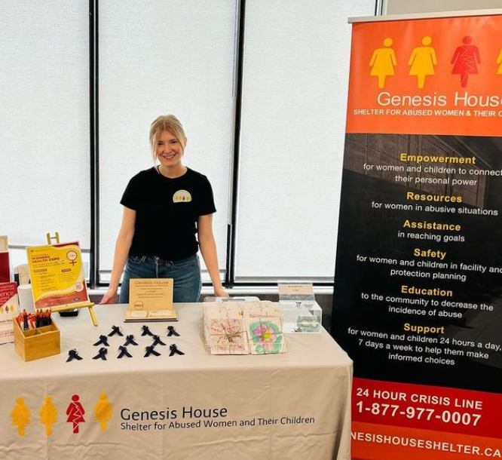

***
Ontario Children’s Need Distribution Centre CAR SEATS FOR INFANTS $2,500
With a $2,500 World Day of Prayer grant, the Children’s Needs Distribution Centre supplied 34 new infant and second-stage car seats to families referred by local social service agencies and a hospital.
Personal Story of One Family: One refugee family who came to Canada from Nigeria in September was expecting twins in December. The pregnancy was high risk as the little girl was not thriving. The family was very grateful for two infant car seats to safely bring home their babies when they were ready to leave the hospital.

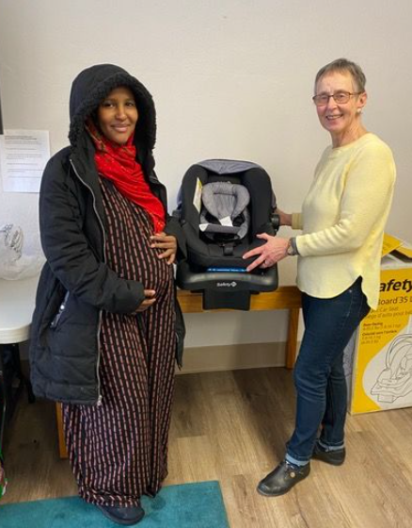

New Brunswick Harvest House Atlantic EMPOWER HER THROUGH EDUCATION – Addiction Recovery $3,000
The project vision for Harvest House in 2023 was to provide enrolment for 10 women in their Addiction Recovery Program. A $3,000 World Day of Prayer grant funded the books and supplies for these women to take part in classes focused on education, empowerment and self-sufficiency – a chance to reclaim their lives.
Class topics included Boundaries, Conquering Codependency, Nutrition for Women's Health, Captivating, Keys to Freedom, Search for Significance, Victory Over Darkness, Bondage Breaker, Relationship Goals, Managing Anger, Journaling and Meditating on God's Word.
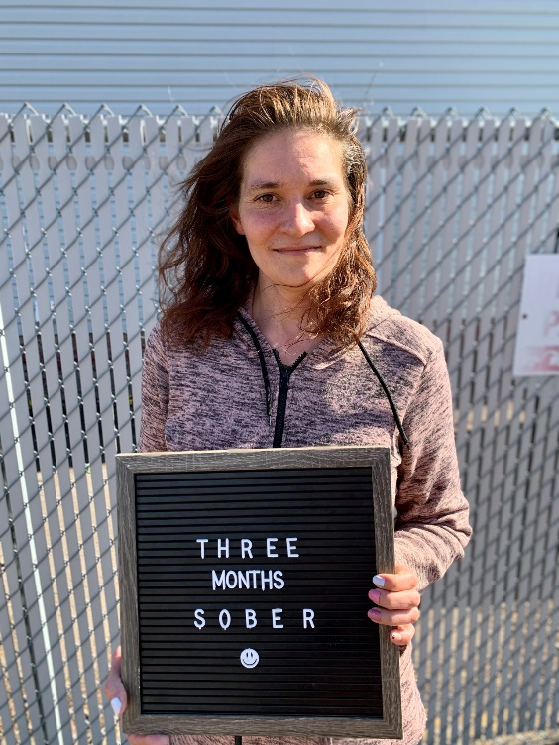
Aygul’s Story
Aygul was born in Ufa, Russia into a Muslim family. Her days were filled with music lessons, ballet, karate, and art classes. Her father and uncle were both alcoholics when she was young, and her parents divorced when she was just 2 years old.
Aygul remembers her first drink vividly. She was 14 years old and at a summer camp. Her friends had wine and cigarettes, so she joined in. This was the beginning of her addiction to alcohol. When she drank, she felt like a leash came off … she was free.
Aygul was pregnant when she graduated from high school. She stayed sober for 1.5 years while pregnant and breastfeeding, but as soon as she was able, she began drinking again. She would drink every night at home, as a stay-at-home young mom. This pattern continued into her 20s and 30s, with alcohol controlling her life.
For the last 19 years, Aygul has been living in Canada. Recently, Aygul experienced a breakup that sent her into a downward spiral. The relationship had provided a slight sense of accountability as she tried to hide her addiction, but suddenly, she was completely alone and sank even deeper into her addiction. She would call a taxi service to bring alcohol to her door, so she would never have to leave the house.
Aygul needed help. She spent two weeks in detox and was told about Harvest House Atlantic’s addiction recovery program. She came to our program simply for a roof over her head and medical care. She had been in two treatment programs before so to her, this was just another program. She soon noticed that the staff genuinely cared for and wanted to help her. After a couple of weeks in the program she started to enjoy a class offered on codependency and began reading her Bible. She said, “I started to like myself sober, then I started really working on myself.” Now, she says she likes what’s going on inside her, and she’s learning to love herself. “Harvest House woke me up.” This is her first time ever genuinely wanting to be sober. She is dreaming, believing, and taking sobriety one day at a time. Her goal every day is to wake up sober and go to bed sober. She feels as though she has been truly reborn.
When asked to explain her sobriety now, she says it’s like a book full of bright colored pages, whereas addiction was all black and white, the same story over and over. Now she gets to write a different story, full of color and hope.

Nova Scotia TREY (Trauma Recovery for Exploited Youth) OUTREACH AND AFTERCARE FOR EXPLOITED YOUTHS $5,000
TREY (Trauma Recovery for Exploited Youth) is a non-profit organization that runs a small, safe, restorative home for young women who have escaped commercial sexual exploitation. Upon reaching a point where the residents feel prepared to transition from TREY, staff recognized the importance of ongoing support in rebuilding lives. Thanks to the World Day of Prayer grant of $5,000 (along with other grants) received in 2023, TREY was able to purchase excellent resource materials – Beyond Trauma - and establish an Aftercare Program for 60 residents It provided emotional and mental health support, assistance with navigating new employment or court obligations, and aids in the establishment of new residences. As well, funding went towards purchases of hygiene products for residents and the establishment of an entrepreneurial program.
Personal tribute: A specific client was assisted with coordinating conversations with various healthcare professionals, particularly in preparation for an impending court case against her trafficker. Plans are in place to connect for a one-on-one coffee outing, as she has been grappling with feelings of isolation.
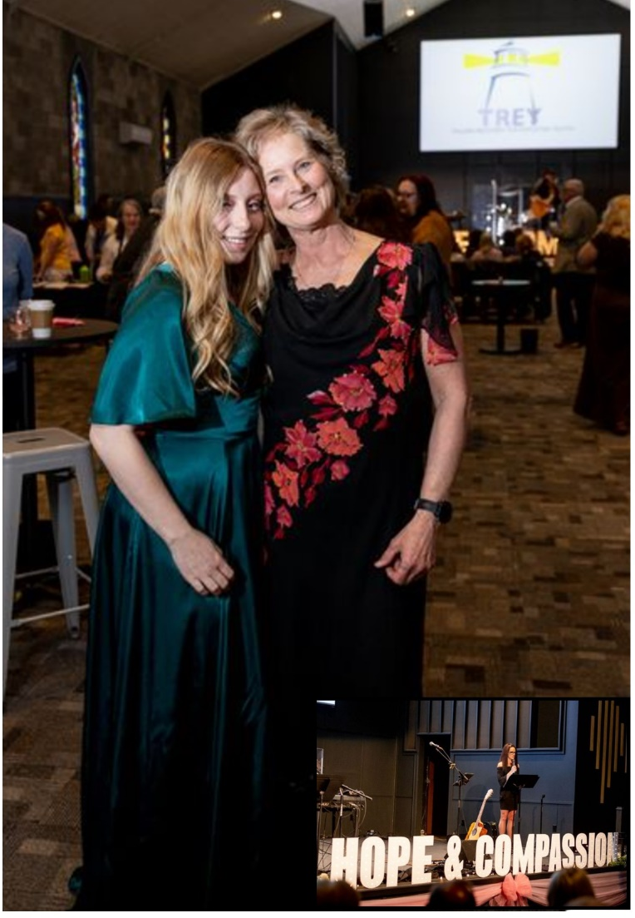

PEI Life House STRENGTHENING WOMEN – REACHING SOBRIETY $2,000
A $2,000 World Day of Prayer grant helped fund a program that empowered and supported 19 women seeking sobriety. Each week, this group met, made a meal together, and interacted with a variety of professional speakers of their choosing. A safe place was created to share difficult stories and form healthy friendships.
Participant Story. After moving back to PEI from Alberta, a Life House resident was struggling to maintain her sobriety, connecting with individuals who used illegal drugs. Many conversations were had with this resident about surrounding people, places & things. We were there for guidance, support and to empower this resident. While at Life House, this resident didn’t only attend our SWG, but spoke to other residents attending the group about the importance of maintaining their sobriety. The resident attributed Life House and its staff to empowering her in maintaining her sobriety, but also for believing in her and allowing her to support others who find themselves going through the same barriers in their lives.

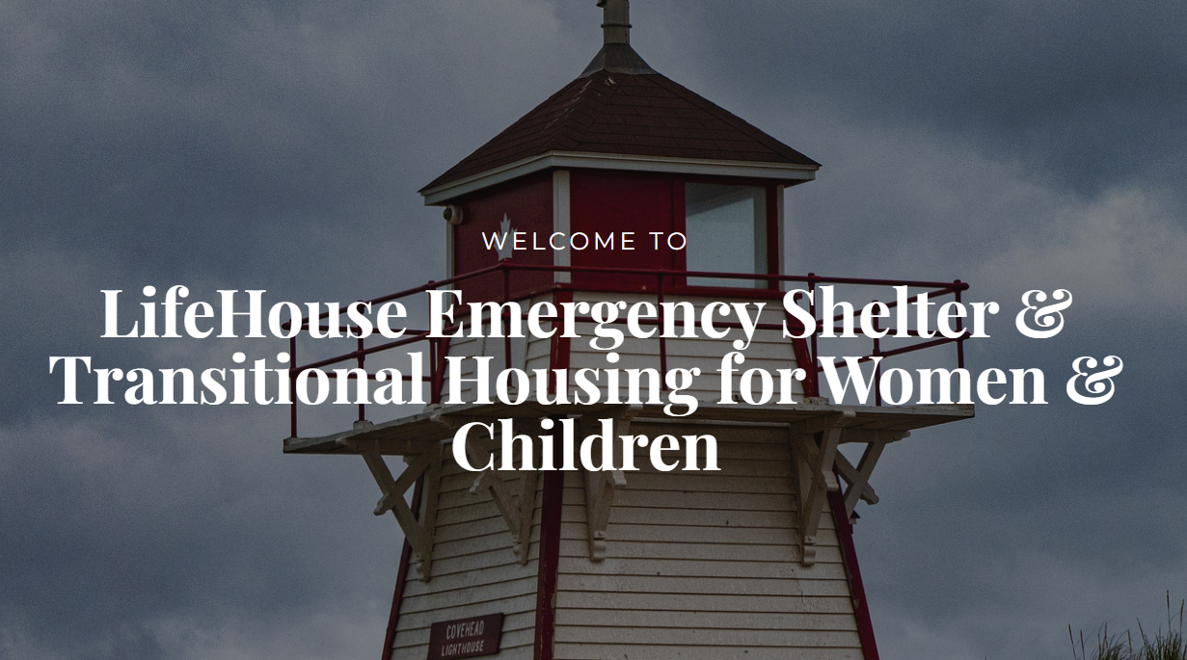

Newfoundland Saltwater Community Association Inclusive Employment $5,000
The Saltwater Community Association of Newfoundland was given a $5,000 World Day of Prayer grant to buy equipment to help create a social enterprise workshop designed to employ individuals with intellectual and developmental disability. Partnerships with local employment organizations advocated for more inclusive hiring practices. Four individuals have participated in the workshop process, so far. The grant was also used to address an immediate need for water and sewer service for the Association building in order for it to be accessible.
Ashley’s Story: For Ashley, this advocacy is more than a cause; it’s a lifeline. A full-time job becomes not just a source of income but a means of breaking free from the shackles of poverty. The prospect of living independently became a tangible reality.
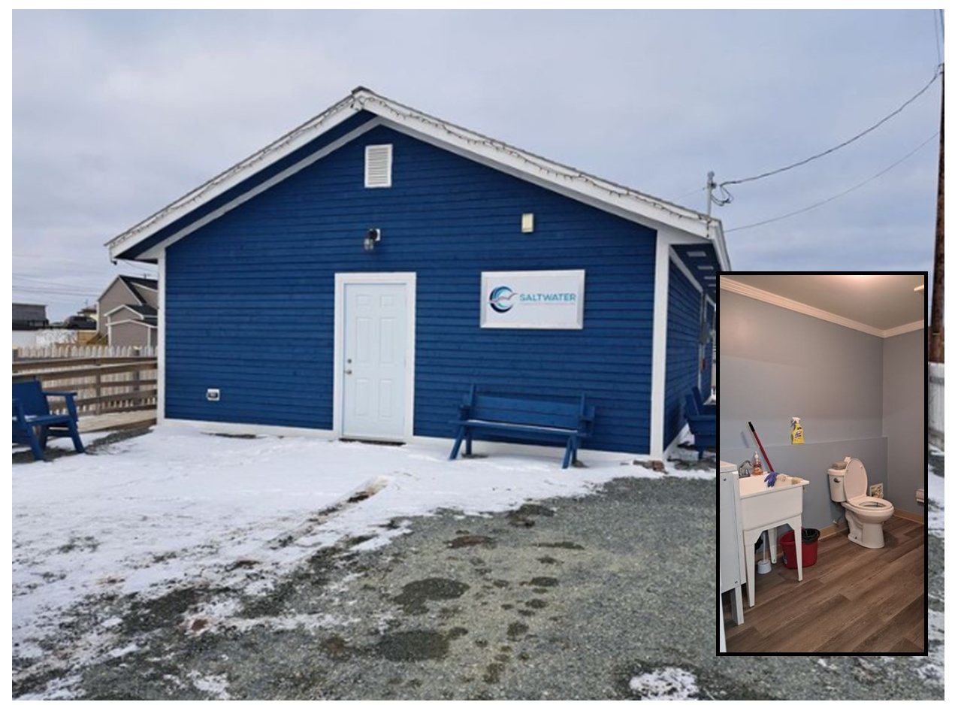

DR Congo Community of Baptist Churches of Eastern Congo PEACE BUILDING TRAINING $5,000
To assist with the reunification of divided factions within the Community of Baptist Churches in East Congo (CEBCE), 35 women leaders spent 4 days with trainers on peace building. During each session, the participants acknowledged the role they played in contributing to the division in their denomination. They wrote down how they felt about it, and, after a time of confession and repentance, burnt the paper in an act of commitment to God. In doing so, they professed that they will no longer be a source of discord. A subsequent session on forgiveness brought together representatives from both majority and minority groups who asked for forgiveness for the wrong each did to the other.​ Training continued with 100 women in 12 ecclesiastical districts.
Madame Eveline’s Story: "I have been a women's leader for 4 years in my ecclesiastical sector of Nyiragongo. But in my way of leading, I had already developed the idea that all the honors should go to me, the others should serve me because I'm their leader, I'm the one who should get the big chunks when he has things to share at the expense of my constituents. Today I repent! May God forgive me for the bad way I treated my sisters in my church. Now I'm committed to putting into practice the recommendations I received in this lesson about the characteristics of a good leader.
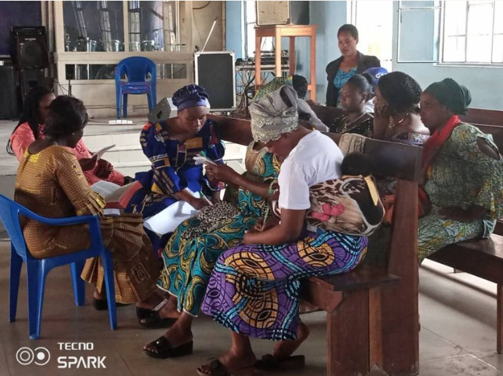
***
Cuba Mosaic Ministries CHILDREN’S ORPHANAGE SUPPORT $5,000
Mosaic Church supports various humanitarian efforts in Cuba. Each year, they visit Holguin to distribute financial support for pastors and their churches and humanitarian support for individuals, including supplies for an orphanage. A $5,000 World Day of Prayer grant supported these initiative as well as Casa Donna, a residence at no charge for parents travelling from outside Holguin who have children being treated at the local hospital.

No personal story
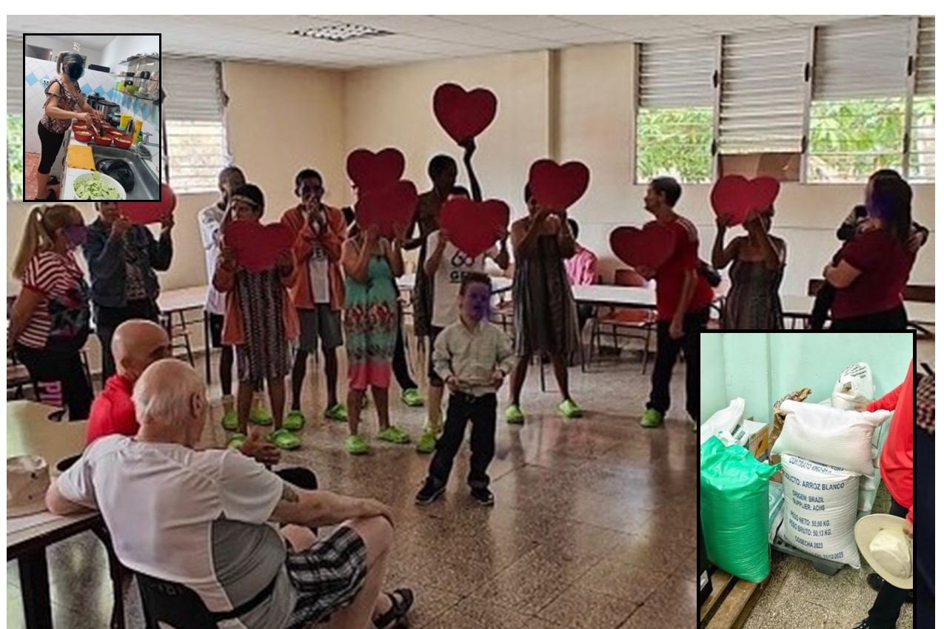
*****
Guatemala International Teams Canada TEACHING KITCHEN & NUTRITION $5,000
The “Building a teaching kitchen and nutrition program in rural Guatemala” project aimed to provide cooking classes and nutritious food to the community of La Pinada, Guatemala. The undertaking addresses the prevalent issue of malnutrition among women and children in the area, aligning with global reports on nutrition. By providing nutritious meals and promoting daily dietary habits, the project empowers young girls to attend and excel in school. The teaching kitchen is also designed to support single mothers, helping them incorporate local produce into meals.
With a $5,000 World Day of Prayer grant, the kitchen was renovated to help 120 children receive healthy meals three times a week, leading to improved school attendance and enhanced learning outcomes. Additionally, 20 youth will soon participate in bi-weekly nutrition and cooking classes, building valuable kitchen skills. Three women have been hired - one as an administrator and director of the centre, and two as cooks.
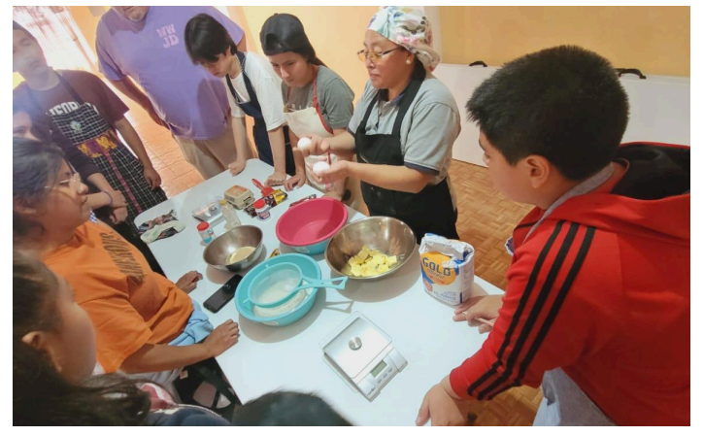

***
Kenya African Christian Church and Schools -Women’s Action HYGIENE HEALTH FOR YOUTHS $5,000
A $5,000 World Day of Prayer grant was gratefully received by the African Christian Church and Schools (ACC&S) – Women’s Action of Thika, Kenya, which purchased hygiene kits for 300 needy students aged 11 to 13 years of age. 180 girls received underpants, sanitary towels, bars of soap, toothpaste, a toothbrush and body lotion. 120 boys received boxer shorts, bars of soap, toothpaste, a toothbrush, and body lotion. The ACC&S has mentored over 1,000 students on the importance of education and resiliency with their first cohort now entering 10th grade.
A personal story from Kariua primary school Headteacher: “My name is Mr. Paul Maina. I want to take this opportunity to thank the group of women from Canada who thought of our children, that is, our boys and girls. I will say thanks because in our country, life has not been easy due to the skyrocketing prices, like in everything, and this has led to many parents concentrating on their basic needs. Sometimes, some of our girls will miss classes when they have their menses, not because they cannot come to school but due to a lack of sanitary towels. I am glad that in the next three months, I will be able to contain all my girls in school because they now feel protected.”

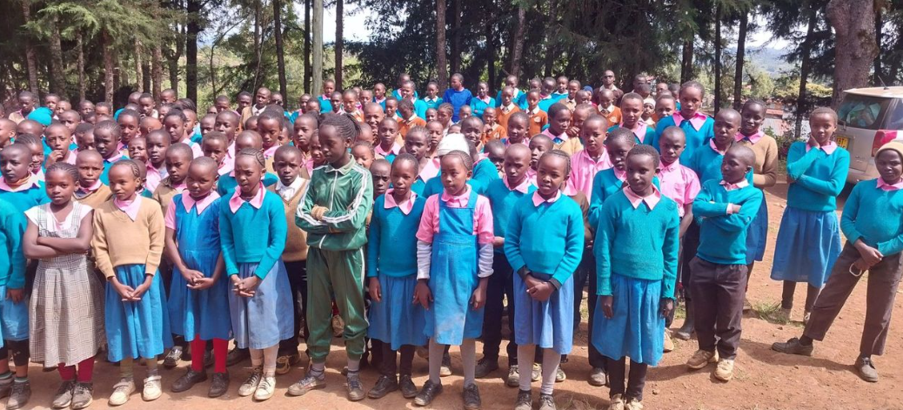
***
Malawi Change Her World PIG HUSBANDRY $2,500
50 women received training on pig husbandry, corral construction and basic care instructions. Next, 25 women received 2 piglets, and in due course as litters happen, each of the remaining 25 women who received training will receive 2 female pigs. Two male pigs were purchased for reproduction purposes.
A $2,500 World Day of Prayer grant paid for the pigs and training process, including notebooks, pens, flip charts and snacks.
Personal Story of Mercy Chiovu: “I am so glad that I was selected to be one of the farmers under this project, I say thank you so much to the directors of Change Her World. At my household level, pig farming once harvesting starts, will enable me to pay school fees for my other children. I will be able to afford good food for my family, hence good health. At the same time, I will use manure from pig Kraal into my garden reducing the cost of fertilizer.”
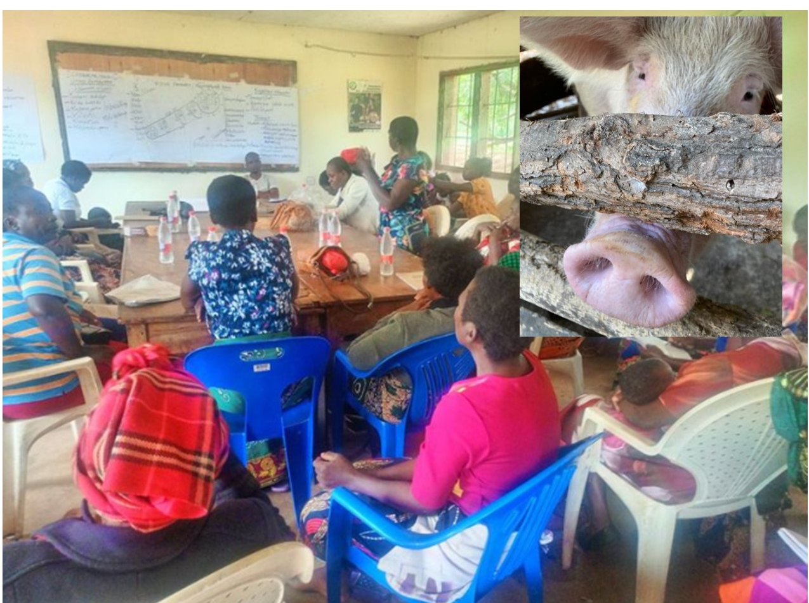
***
Philippines Luzon Convention Baptist Women Missionary Union CLIMATE CHANGE FORUM FOR CHURCHES $5,000
Climate change is of great concern to the Philippines, especially since respiratory problems have become rampant due to heat and pollution combinations. A government bill was introduced in November 2023 intended to institute policies and systems to address damages and losses from climate change. A $5,000 World Day of Prayer grant assisted Baptist Women in preparing for a Climate Crisis Forum, which was attended by 53 participants. Resources were prepared and distributed to local churches and ecumenical groups under the title of “Creating a Wonderful World”. Workshops were led for teachers. The next step will be encouraging local responsibilities in a grassroots effort.
Personal Story: None
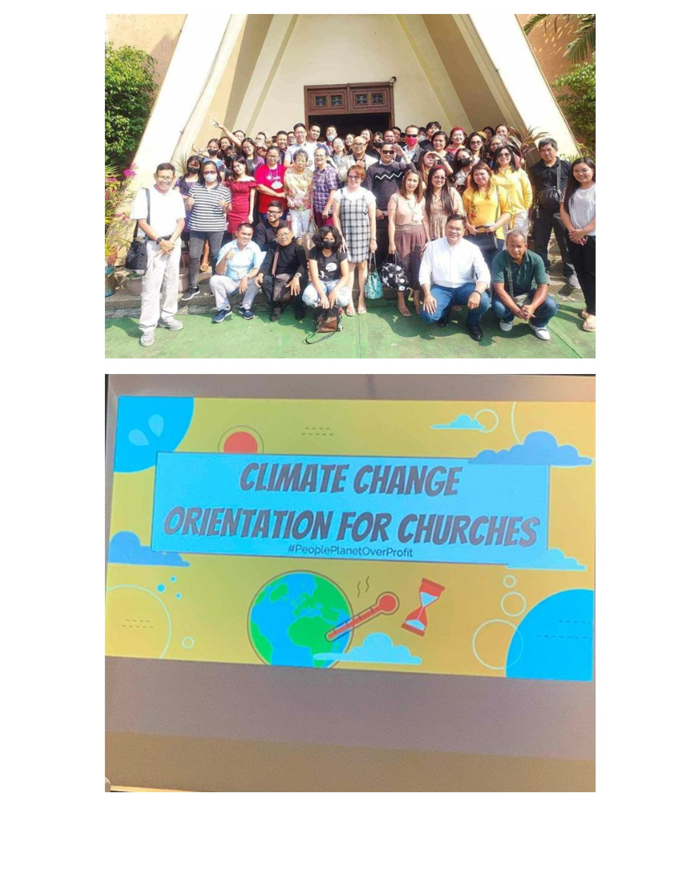
Reference Chart
British Columbia | Multi-Nation Missions Foundation | Preparing Immigrant Women for Canadian Employment | $5,000
British Columbia | The Salvation Army - The Willows | PEACE Program – Leaving Violence | $5,000
Manitoba | Genesis House | When Love Hurts Support Program | $4,500
Alberta | IWIN | Backpacks for Trafficking Survivors | $3,500
Ontario | Children’s Need Distribution Centre | Infant Car Seats | $2,500
New Brunswick | Harvest House Atlantic | Addiction Recovery for Women | $3,000
Nova Scotia | TREY (Trauma Recovery for Exploited Youth) | Outreach and Aftercare for Exploited Youths | $5,000
PEI | Life House Summerside; | Strengthening Women – Reaching Sobriety | $2,000
Newfoundland | Saltwater Community Association | Inclusive Employment | $5,000
INTERNATIONAL
Kenya | African Christian Church and Schools ACC&S | Hygiene Health for Youths | $5,000
Philippines | Luzon Convention Baptist Women Missionary Union | Climate Change Forum for Churches | $5,000
Malawi | Change Her World | Pig Farming | $2,500
Guatemala | International Teams Canada | Teaching Kitchen & Nutrition | $5,000
Cuba | Mosaic Ministries | Orphanage Support | $5,000
DR Congo | 55th Community of Baptist Churches East Congo | Peace Building Training for Churches | $5,000

